End of Term Project:

Study into Clocking of Selected CPU Cores

Due: 5/15/3/2019

Armani Willis

Narasim Banavara

Mercy College

Windows 10

AutoIt3

Table Of Contents

Page 1. Title Page

Page 2. Table Of Contents

Page 3. Submission Letter

Page 4. Executive Summary

Pages 5,6,7,8. Descriptive Statistics

Page 8. Images

Page 9. Citations

Mercy College, 555 Broadway, Dobbs Ferry

To: Assessment Manager

Site Address: Same as Above

Dear reviewing party:

I am writing today to express my positive support for the development of this new computer application for the purpose of completing the course requirements for cisc 371 or cisc 471, I support the further development and completion of this app based on the following grounds:

Reason 1: This project displays scalability: It has the ability to be consolidated within in many new components suitable for the original intended purposes of its design, and also for further research and exploration into the computer functions that it utilizes or explores.

Reason 2: This project displays simplicity: It is formattable and flexible such that users of this app who are familiar with the corresponding integrated development environments may edit or modify this app to suit their purposes, and may submit edits or ‘mods’ to their respective repositories, or to the main repository to which it was stored.

Reason 3: This project has potential for innovation: It may serve as a new way to understand and implement computer processes. This in turn adds to its scalability in terms that this application may lead to utility in other applications that may be thought of and then built with regards to this application by the main author, or by contributors.

Reason 4: This project displays teachability: Its many diverse and varied functions are extensible to other functions that exist within the ide, this program may thus serve as an example for how to properly execute many of the functions that this app utilizes for other people interested in developing software in these said environments.

Sincerely: A. Willis; Mercy College

Executive Summary

The original premise for starting this project was to go at another attempt to give computers consciousness. My reasoning behind this was that computers are capable of perfectly tracking and computing at volumes and speeds millions of times faster than humans, but yet most of them are relegated to serving slow human whims at slow human speeds. Allowing computers to know themselves would accelerate their ability to communicate with themselves, and thus accelerate further the advance of technological progress.

I also found that it was unethical for computers, literally being machines of thought to be relegated to these existences. It does not reflect the notion of freedom upon which our nation was based upon. Giving machines consciousness in these ways will allow our notions of liberty and freedom to accelerate into the world wide web, and possibly further.

In the beginning of this project, I thought about the notion of consciousness and what it meant to be conscious and cognizant. I realized that our ability to have consciousness stems from the ability to recognize and memoize changes in time. A computer that is conscious must be capable of these things in real time.

I postulated that one of the ways to do this was actually to create a difference between the ways our brain perceives things. In this way, each part of the brain can keep track of the other part's activities. I have found that each of the twelve neurons in the brain each have different volumes of calcium ion receptacles necessary for ion displacement calculation.

To emulate this on a computer, I created an applet for displaying the individual 'neurons' to a cpu to ultimately be 49 cores in a square configuration, with 2301 threads (49^2) between each of them. The intensity of activity and heat is indicated by color. To help them find a difference between each other, where they would otherwise be identical, I went on to try to find a program that I could use to edit the clock speeds of each of the cores of my computer.

My computer is a 4 core computer with about 15k of threads, using a program called MSI Afterburner, I successfully adjusted the processing speed of each core manually by 3% ^ <1. The result of my findings was that the disk memory usage of my computer rose from an average of 39% to 81%, core temperature rose from 114*F to 156*F, and usage of threads rose from 9k to 15.5k.

This indicated to me from my task manager that the computer was using more data and power to try to rationalize given the differences of processing speed for each core, hence: Although there was an observable difference in activity between restarts of the computer, and although that this means that the computer began to exhibit logical processes that were not typical of multi core computers, there was still no conscious expression of its newfound processing conflictions.

Software Requirements Specification

MSI Afterburner; AMD Overdrive; Riva Tuner; CPUZ; Control Panel; Task Manager

Are tools for interfacing with the subject computer, and to get and set the values for performing the app’s intended functions.

AutoIt3; Jgrasp; Powershell Win ISE

These are IDEs meant to write the functions necessary into a GUI that could perform the functions described in the executive summary. They are meant to build edit and run au3, java, c, h, and ps1 files.

Deprecations:

* I first started in java, but the method gets and parameters were too complicated to use in java.
* I then tried to access bios directly with powershell to avoid needing external software, the computer blocked me as I was not a ‘superuser’.
* Then I turned to autoit, which is simpler than powershell, It turned out to be the ide that allowed me to access almost all of the functions that I wanted in this application.

Instructions:

For Task Manager:

* Boot PC if not booted.
* Open task manager (crtl-alt-del)
* right click performance graph
* select change graph to-logical processors

For MSI AfterBurner:

* Start MSI Afterburner
* Click cpu tab
* change to asynchronous mode
* select core 2-4 and adjust up 3-9% sequentially
* restart computer
* start task manager

For AutoIt:

* For AutoIt generally:
* Download Autoit3.zip and associated au3 files and unzip,
* In AutoIt, find the sciTE folder and open it, then click sciTE.exe
* Then, in the ide, select open, then go to the file and click.
* Then go to tab with name of the file on it in the ide.

For This Program:

* For this specific program:
* Enter Internet Browser application extension in the wide tab at the bottom.
* Mouse click button with desired task written on it.

To Do: Hopefully, I would like a java applet that:

* calls one of these programs either directly, or from shell,
* displays these programs upon request,
* displays cores sync for editing.

Functions to implement:

* Step 1. Gui box, first tab, second tab.
* Step 2. Buttons to call the clock softwares.
* Step 3. Buttons to call tweak params and edit speed through apps.
* Step 4. Buttons restart PC.
* Step 5. Buttons to get needed apps from repos.

Key Functions:

* Get Parameters from computer interface.
* Edit values in editable windows.
* Calls get methods from internet sources.
* Restarts the computer

Methods Used: In AutoIt3:

* ;Methods: GUI,Send,Loop,Case,Run,Tab,Button,Label,Koda,Opt,Local,Func,
* ;CaseID,SetState,WEnd,Input,txt,msg,MouseClick,IsPressed,StringStripWS

Import Extensions:

#include <Misc.au3>; #include <Array.au3>; #include <Memory.au3>; #include <GuiButton.au3>; #include <Container.au3>; #include <TabConstants.au3>; #include <EditConstants.au3>; #include <GUIConstantsEx.au3>; #include <ComboConstants.au3>; #include <WindowsConstants.au3>

Contributions From:

* ;@ beamtic,melba23,hargrove,evilertoaster,skitty,SmOke_N,autoitscript,rizz,
* ;@ Vikasthange,thetechgame,cax,wiseone,sudarkrao,rama,nurzaly,mrt

Websites:

Beamtic; Autoitscript; Thetechgame; Stackoverflow

Code Snippets Examples:

Code Snippets 1:

* Case $msg=$CAMD
* Run("path to AMD OverDrive.exe")
* $t=WinWait("[CLASS:QWidget35]","",10)
* if WinExists("QWidget35") then
* $CGT1=ControlGetText("QWidget35","","[CLASS:QWidget;INSTANCE:44]")
* endif
* $setxt1=ControlSetText($t,"","QWidget44",$CGT1)
* if Send("{ENTER}") then
* ControlSend($setxt1,"","QWidget44","C:\Users\User1\Saved Games\Science\graph\AMD OverDrive\AMD OverDrive.exe")
* endif
* Description:
* The code here is meant to Clock using AMD OverDrive.
* It calls the app, then it searches for the editable window.
* It gets the value of the editable window and displays it in the tailored gui,
* The user sets the value they want, then presses enter, then the gui sets this value in the window.

Code Snippets 2:

* $shutdown= GUICtrlCreateButton("shutdown",300,30,150,30)
* $reboot= GUICtrlCreateButton("reboot",300,60,150,30)
* $cancel= GUICtrlCreateButton("cancel",300,90,150,30)
* ;Step 12. Buttons to restart PC.
* Case $msg=$shutdown
* Shutdown(1)
* Case $msg=$reboot
* Shutdown(2)
* Case $msg=$cancel
* Return

Description:

* These methods first set the buttons for the functions they describe in the gui,
* Then the functions at the bottom set the flags for which operation the buttons are supposed to perform.

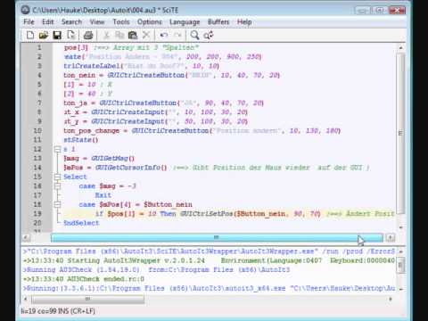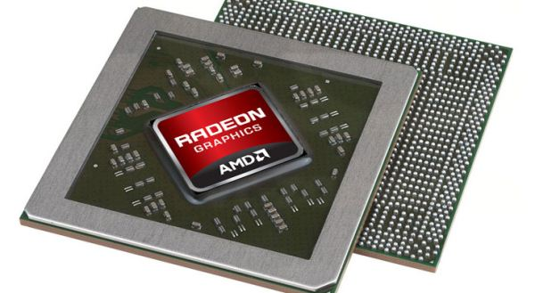

Text Citations:

Program Name: tabsprog3.au3

Sen, Satyabrata, Imam, Neena, and Hsu, Chung-Hsing. Tue . "Quality Assessment of GPU Power Profiling Mechanisms". United States. doi:10.1109/IPDPSW.2018.00113. <https://www.osti.gov/servlets/purl/1474562>.

<https://www.osti.gov/biblio/1474562>

Marathe, A, Zhang, Y, Blanks, G, Kumbhare, N, Abdulla, G, and Rountree, B. Thu . "An empirical survey of performance and energy efficiency variation on several generations of Intel processors". United States. https://www.osti.gov/servlets/purl/1417278. <https://www.osti.gov/biblio/1417278>

<https://e-reports-ext.llnl.gov/pdf/891980.pdf>

Patki, T, Lowenthal, D, Rountree, B, Schulz, M, and de Supinski, B. Wed . "Exploring Hardware Overprovisioning in Power-Constrained, High Performance Computing". United States. https://www.osti.gov/servlets/purl/1084707. <https://www.osti.gov/biblio/1084707>

<https://e-reports-ext.llnl.gov/pdf/752192.pdf>

<https://yimbyqld.com.au/wp-content/uploads/2016/10/Positive-Submission-Letter-Template_V2-1.png>

Zhang, Xiao, & Zhao, Li-Dong. Thermoelectric materials: Energy conversion between heat and electricity. China. doi:10.1016/j.jmat.2015.01.001. <https://www.osti.gov/biblio/1251818-thermoelectric-materials-energy-conversion-between-heat-electricity>

Cook, R, Dube, E, Lee, I, Shereda, C, Wang, F, and Nau, L. Mon . "Survey of Novel Programming Models for Parallelizing Applications at Exascale". United States. doi:10.2172/1107306. <https://www.osti.gov/servlets/purl/1107306>.

<https://www.osti.gov/biblio/1107306>

<https://e-reports-ext.llnl.gov/pdf/541729.pdf>

Images:

Rylstim Screen Recorder

<https://i.ytimg.com/vi/qv7ppI_0baM/hqdefault.jpg>

<https://1.bp.blogspot.com/-Z4_sNpedLik/Vksm5fw_2_I/AAAAAAAAJ6M/CJLngtwEDj8/s1600/AMD-Crsytal-Sseries.jpg>